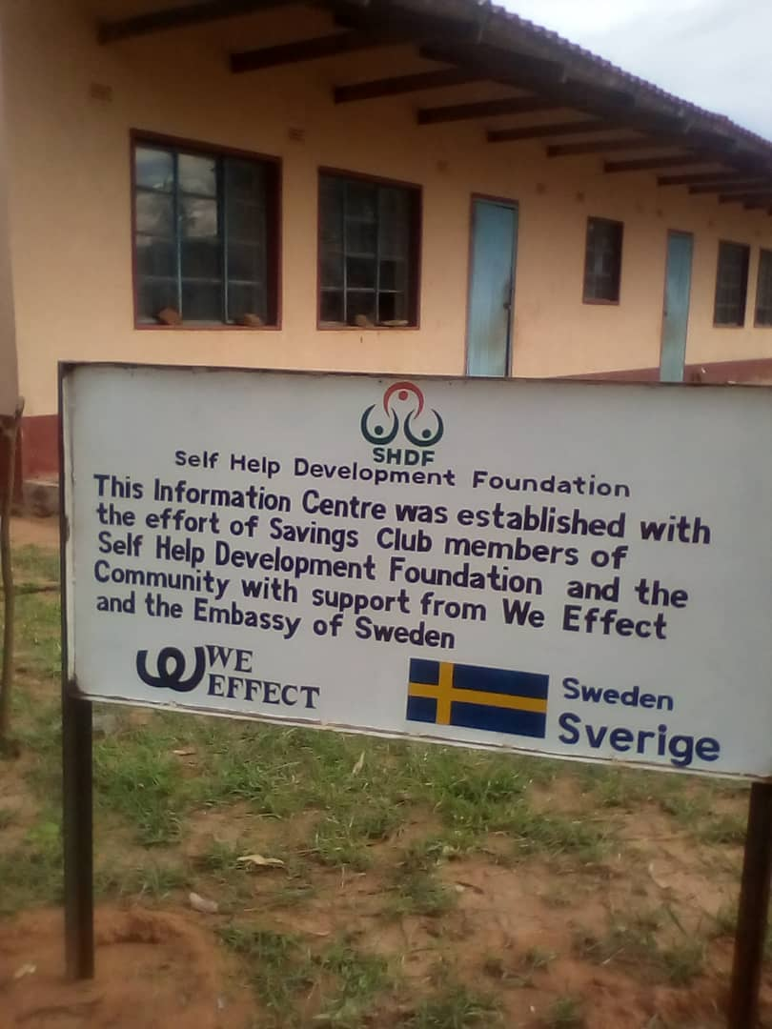
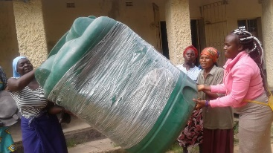

v

………As Green EBDP breathes new life to Siphathisiwe Ngoma

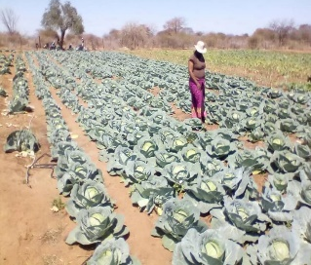
Siphathisiwe Ngoma, 44 hails from Magaya village in ward 17of Gwanda district. She is married woman and a mother of 5. Siphathisiwe is a qualified primary school teacher who for a long time had the zeal to become her own boss but lacked capacity in the areas of running a viable horticulture business. She joined SHDF in 2018 at the inception of the Green Enterprise Business Development Programme (GEBDP) in her wards after she felt she fitted well in the programme. Upon joining, she received several trainings and among them was, How to start and improve your business and she quickly decided to scale up her business of horticulture which had started small in an area of 0.5 hectors in 2017 to 2 hectares. From her savings and support from the husband she procured herself some solar panels and drip liners to upgrade her farming system from the bucket watering system she was doing before.

Since joining Siphathisiwe became an active member of SHDF where she attended the commodity association training in Harare and upon returning home, she managed to mobilize other farmers in her areas into a commodity group. She was crowned the “Woman entrepreneur of the year 2020” and received a wheel barrow and a garden folk. From her two hectares in the year 2020 she had planted 19 000 plants of onion, 8000 plants of cabbage, 5000 plants of rape, 5000 plants of chaumolier and 16 000 plants of tomatoes. Her project is not only benefiting her immediate family but the community of about 40 households who buy vegetables from her. Siphathisiwe has created jobs for women and youth in her ward who include 6 people doing land preparation, 8 people on tomatoes, 10 people on harvesting, 6 people on vegetable processing, 10 people on transplanting and 2 people on weeding.
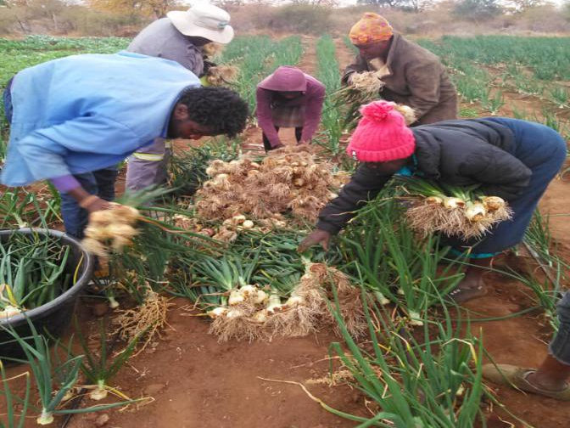
Siphathisiwe’s employees sorting produce for the market

Between 2019 and 2020 Siphathisiwe’s income trebled to R47 000 compared to the year of 2017 when she made only R 10 000 from the 0.5 ha. Siphathisiwe managed to send one of her children to a private school. She also bought a truck that she uses for the deliveries of produce to the market. She has also extended her house at home and added a number of goats in her kraal.
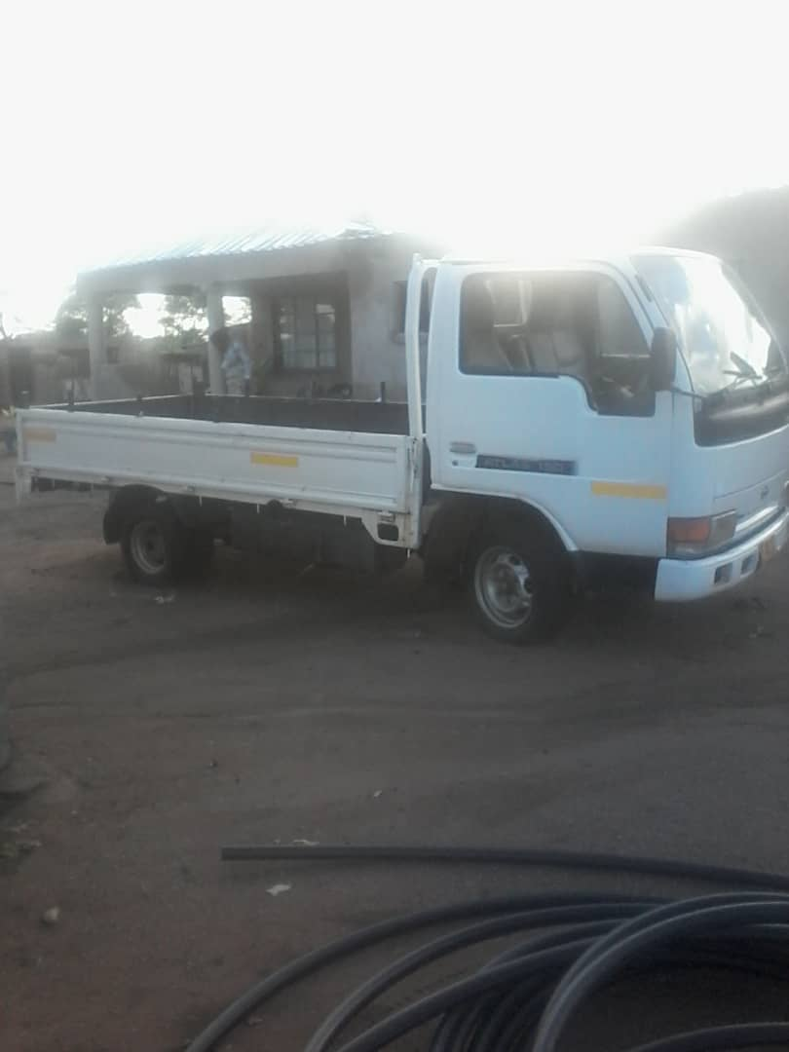
The vehicle that Siphathisiwe bought using returns from her enterprise

Siphathisiwe quotes “I am not regretting resigning from my job as a teacher in 2018 to become my own boss and making a better living. I got to know about SHDF at the right time. The business mentorship sessions and study circle books that I have received from the organisation are on point in shaping my enterprise, I have learnt a lot and wish to learn even more. SHDF has through GEBDP increased my financial independence and has breathed a new wave of life to my family and I am grateful for that”.

